Requirements/Design Specification

**July CRM Enhancements**

**CR 14090**

Revision History

|  |  |  |  |
| --- | --- | --- | --- |
| **Date** | **Revision** | **Description** | **Author** |
| 5/18/2015 | 1.0 | Initial Version with Requirements | Roger Behm |
| 6/1/2015 | 1.1 | Added requriements and design details for GH issues up to #640. | John Palubinskas |
|  |  |  |  |
|  |  |  |  |
|  |  |  |  |

The information furnished herein by Republic Services Inc. is proprietary and confidential to Republic Services Inc. personnel and is not to be duplicated, published, or disclosed to any third party in whole or in part without permission from Republic Services, Inc.

© Copyright 2015, Republic Services Inc. - All rights reserved.

Table of contents

1 Business Requirements 6

1.1 Purpose of the Design Specification 6

1.1.1 Bug list for current release 6

CRM - Site environment text overlaps main nav 6

2 Assumptions 7

3 Design 7

3.1 #609 CRM – Site Enviornment Test Overlaps Main Nav 7

Issue 7

4 InfoPro Interface 7

5 Report Changes 7

6 Appendix 7

# Business Requirements

## Purpose of the Design Specification

This document highlights items to be fixed and implemented for the titled release.

### Bug list for current release

| GitHub Item  Number | **Description** |
| --- | --- |
| 589 | CRM – Import competitor into config |
| 590 | CRM - Skip first two screens when entering from SFDC |
| 591 | CRM – Additional Integration Attributes needed |
| 592 | CRM – Replicate product upsert changes to all XSLs |
| 593 | CRM – Implement invalidation of quotes from SFDC |
| 602 | CRM - Add SFDC connector to Capture Train and link SFDC Training |
| 604 | CRM - Fonts and styles in Capture should match Salesforce |
| 605 | CRM – Calculate Price vs Calculate Total Price |
| 607 | CRM – attribute sfdcRunUpserts_quote does not flip to True when it should |
| 608 | CRM – fix behavior of opportunity stage_quote |
| 609 | CRM - Site environment text overlaps main nav |
| 615 | CRM - Clean invalid characters passed in site addresses |
| 616 | CRM - Import EIN from SFDC user record |
| 618 | CRM - Import Infopro Division Number from SFDC |
| 633 | CRM - update Area field import to handle full area name |
| 637 | CRM - Copy Expired Quotes |
| 640 | CRM - Account field in header editable on Change of Owner |

# 

# Assumptions

NA

# Design

## #589 CRM – Import competitor into config

## Issue

The competitor code is going to be passed in from SFDC opportunity to set the default value on the competitor dropdown. That field needs to be mapped in the integration XSL, and BML needs to be written to properly set the value.

**Design**

TBD

**Downstream Impacts (TIBCO, BI, InfoPro)**

None

## #590 CRM - Skip first two screens when entering from SFDC

## Issue

As the first two screens in Capture are being populated directly from the SFDC Opportunity, there is no need for a user entering from SFDC to see those two non-editable screens. A request was made to skip those two steps when entering a quote from SFDC.

If this enhancement is implemented, the quote description field on the initial step will need to be relocated to another quote-level screen.

**Design**

TBD

**Downstream Impacts (TIBCO, BI, InfoPro)**

TBD

## #591 CRM – Additional Integration Attributes needed

## Issue

The following fields need to be mapped between SFDC and Capture:

* Line: frequency
* Line: waste stream
* Header: Segment
* Header: deliver and service notes **Note that these are now line level, not header**
* Header: Unsigned CSA Reason, Rejection Reason, Finalize comments, PO number

**Design**

TBD

**Downstream Impacts (TIBCO, BI, InfoPro)**

TBD

## #592 CRM – Replicate product upsert changes to all XSLs

## Issue

Due to SFDC API governor limits, only 200 records can be created at a time. There are 5 product upsert integration XSLs, to support up to 1000 lines. Changes were only made to the first XSL, supporting 1-200 lines/products.

**Design**

Update the following integration XSLs to match the implementation in quote_process.crmProduct200Ids_quote:

* quote_process.crmProduct400Ids_quote
* quote_process.crmProduct600Ids_quote
* quote_process.crmProduct800Ids_quote
* quote_process.crmProduct1000Ids_quote

**Downstream Impacts (TIBCO, BI, InfoPro)**

None

## #593 CRM – Implement invalidation of quotes from SFDC

## Issue

Implement validation to not allow quotes invalidated by SFDC to move forward in the quoting process. We still want users to be able to view invalidated quotes in Capture, but we do not want any information to change on the quote if the user enters the quote to view it.  
  
The first thought on development is to set the quote status to expired if a user comes in to view the quote. If they don't view an invalidated quote, it will expire in 90 days anyhow.

**Design**

TBD

**Downstream Impacts (TIBCO, BI, InfoPro)**

TBD

## #602 CRM - Add SFDC connector to Capture Train and link SFDC Training

## Issue

The Oracle managed connector needs to be installed and configured in SFDC. This will allow SFDC users to create new quotes in Capture Training from the SFDC Training environment.

All users that will be performing that function will need to be added as users in the Capture Test environment with their SFDC FullSB login in the partner login field of their User profile.

**Design**

Follow Oracle CPQ managed connector installation guide.

Work with Sakshi to get admin account on SFDC FullSB and configure Salesforce side.

**Downstream Impacts (TIBCO, BI, InfoPro)**

None

## #604 CRM - Fonts and styles in Capture should match Salesforce

## Issue

The read-only header font is much smaller than most other items in Capture and Salesforce. There was a request to update those to match Salesforce.

[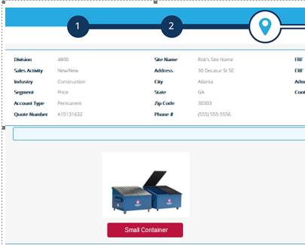](https://cloud.githubusercontent.com/assets/7797351/7597764/855b10bc-f8aa-11e4-856f-9a6d4fd8555b.png)

**Design**

We will not be changing the font face to match SFDC since they're using Arial, and we're using Open Sans per the Republic Services style guide. However, we should make updates to the font size used in the header in config and commerce. Changing the font size will result in items shifting around in the header, so there may be a bit of trial and error to see the best way to lay it out.

For the Commerce header, update devrepublicservicesAlt.css to not force the font-size to 11px on infobar div span.readonly-wrapper. That will result in the font being bumped to 14px via the .readonly-wrapper style. The header layout will have to expand the size needed for the labels as **Quote Number** will wrap at the larger size. Also need to resize the layout columns to make room for larger email addresses.

For Config, we need to replicate the same HTML in the config attribute. We should be sure all styles are broken out into CSS if they're currently embedded in the HTML.

**Downstream Impacts (TIBCO, BI, InfoPro)**

None

## #605 CRM – Calculate Price vs Calculate Total Price

## Issue

Users are getting confused with the usage of the Calculate Price button versus the Calculate Total Price button. Can we combine these actions into a single, Calculate Price button?

**Design**

Need to rework the quote layout to hide the currentQuoteTotal_quote attribute, and potentially shift around all items in that section to create a nice layout.

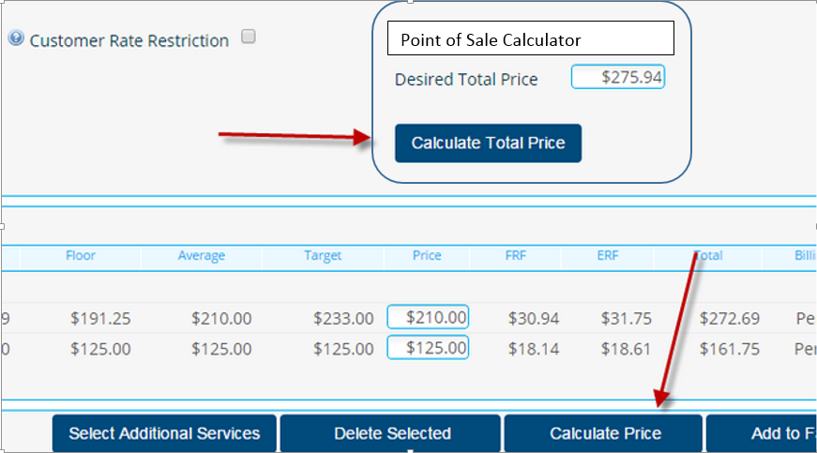

**Downstream Impacts (TIBCO, BI, InfoPro)**

TBD

## #607 CRM – attribute sfdcRunUpserts_quote does not flip to True when it should

## Issue

sfdcRunUpserts_quote is used as a condition in the quote and product upsert XSLs, and it is meant to prevent the creation of empty quotes in SFDC. To this end, sfdcRunUpserts_quote should flip to True as soon as there are line items on the quote, which should happen once the hiddenAction runs. However, currently, it only flips to True once the user is forced to click the "Calculate Price".

One solution is to set it to True on the line default action.

**Design**

Modify prePricingFormulas to set sfdcRunUpserts_quote to true. This function is run on the transition from config to commerce so it should work as intended.

**Downstream Impacts (TIBCO, BI, InfoPro)**

None

## #608 CRM – fix behavior of opportunity stage_quote

## Issue

opportunityStage_quote should be set to "Propose" when the user moves out of "Generate Docs" by clicking clicking Next (finalizeQuote_quote), even if the document was not printed or emailed.

**Design**

Modify the commerce function setStatus to set opportunityStage_quote to Propose when actionName == "finalizeContract"

**Downstream Impacts (TIBCO, BI, InfoPro)**

None

## #609 CRM – Site Enviornment Test Overlaps Main Nav

## Issue

When accessing Capture via SFDC, the site environment label that we pin to the top of every page can prevent access to the navigation menu. This is a result of hiding the Capture and Republic logos on SFDC quotes.

**Design**

Move the conditional logic for setting the environment from the header.html to sitewide.js.  
Move the .environment style to capture.css since that is loaded from the header.html.  
Change the output label to say *Environment: environment name* where the different environments are:

* Dev
* Dev 2
* Test
* Test SFDC
* Training
* (blank for production)

**Downstream Impacts (TIBCO, BI, InfoPro)**

None

## #615 CRM - Clean invalid characters passed in site addresses

## Issue

SFDC doesn't reformat their address data into a format that Bing maps likes. We need to clean up the address data on the Capture side to handle the handful of characters that will cause the Bing address lookup to fail.

**Design**

In the util function getGeoCodesFromAddress, parse the siteStreet and siteCity values, and replace all punctuation with blanks or their corresponding ASCII character codes before calling the Bing Maps API.

May require an update the the maps data table if we change how we are passing the address to Bing.

**Downstream Impacts (TIBCO, BI, InfoPro)**

None

## #616 CRM - Import EIN from SFDC user record

## Issue

The SFDC User record has an EmployeeNumber field that will be populated with the InfoPro Employee Identification Number (EIN).

**Design**

We need to create a new quote level attribute in Capture called Employee Identification Number (suggestion varname: ein_quote), update the user import XSL, and map the aforementioned SFDC EmployeeNumber to this newly created ein_quote.

**Downstream Impacts (TIBCO, BI, InfoPro)**

New text field attribute ein_quote

## #618 CRM - Import Infopro Division Number from SFDC

## Issue

SFDC InfoPro_Number__c needs to be mapped to Capture's infoProDivision_quote.

**Design**

Modify the opportunity import XSL to import InfoPro_Number__c and map it to Capture's infoProDivision_quote.

In testing, please ensure that the value from infoProDivision_quote propogates correctly to infoproDivision_RO_quote is and infoProNumberDisplayOnly_quote.

Also note that any attribute defaults on the infopro numbers may have to be updated with conditions on sourceSystem_quote.

**Downstream Impacts (TIBCO, BI, InfoPro)**

None

## #633 CRM - update Area field import to handle full area name

## Issue

CRM requested we change how we are pulling in the Area field from SFDC in order to handle the entire Area label value coming through 'A01 - NEW ENGLAND/NY', instead of just the Area number 'A01'. This will make it easier for their implementation of that field in SFDC.

**Design**

Update the importOpportunity_process_generator and _parser to handle the shortened Area field.

**Downstream Impacts (TIBCO, BI, InfoPro)**

None

## #640 CRM - Account field in header editable on Change of Owner

## Issue

There are certain screens where the Account field in the commerce header is editable when it should always be read-only. Additionally, on all expired or abandoned quotes, there are many fields that are editable that should not be.

**Design**

Set as non-editable or hidden, all fields for SalesRep – Expired, Abandoned, Deleted. Details TBD.

**Downstream Impacts (TIBCO, BI, InfoPro)**

None

# InfoPro Interface

No new variable should be needed and no existing variables should be repurposed for any of the above changes.

# Report Changes

NA

# Appendix